To Publish the Power BI Dashboard
- Click Publish
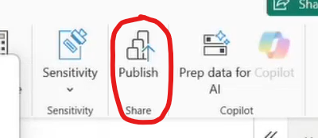
- Choose where you want to publish the report. In this case, we choose the AIDE_0088239 Workforce Star Consumer [Dev]
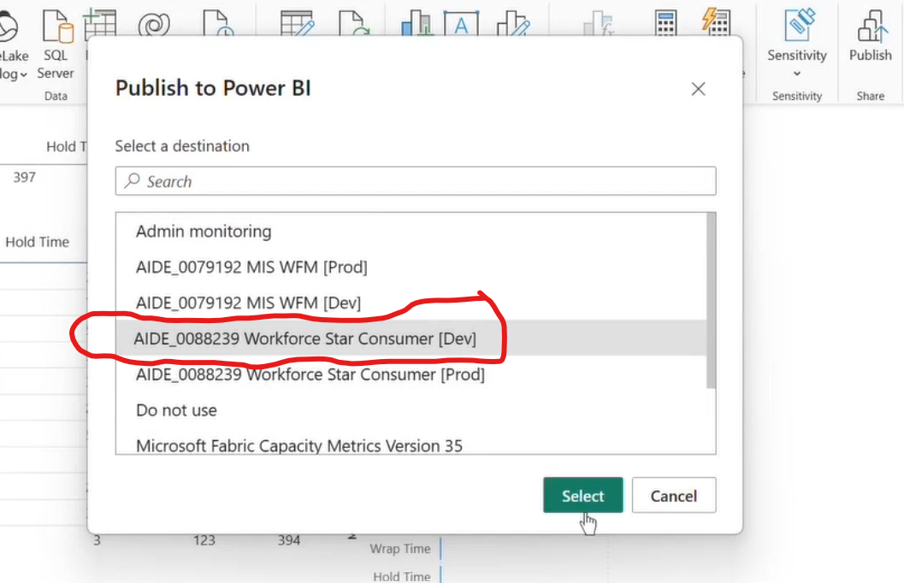
- This will appear. Just ignore it and close it.
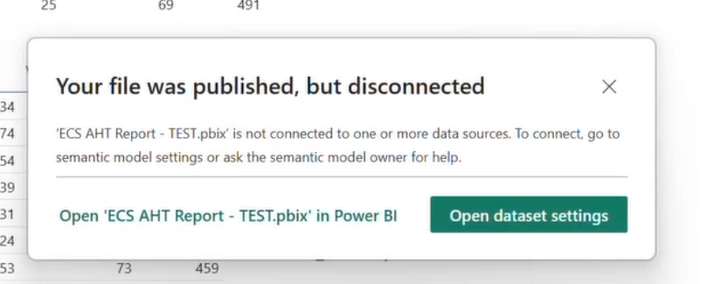
- Browse for the Power BI website. https://app.powerbi.com
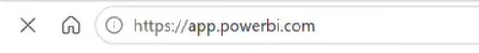
- Click your Workspace
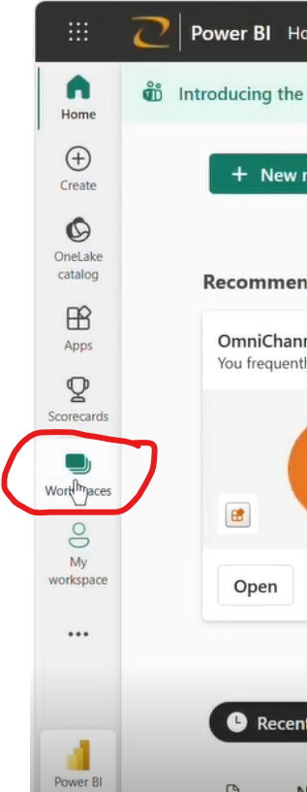

6. Choose where you publish the report earlier. Choose AIDE_0088239 Workforce Star Consumer [Dev]
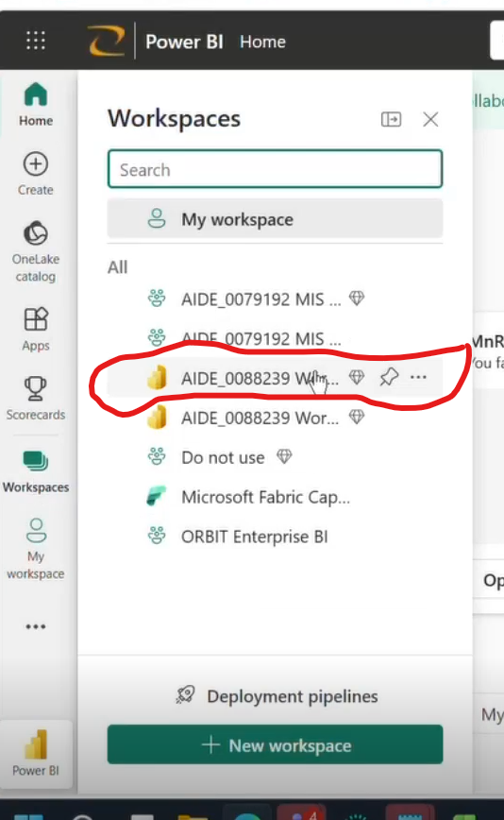
- Find the report you deploy. Choose the Semantic model. Click the 3 dots …
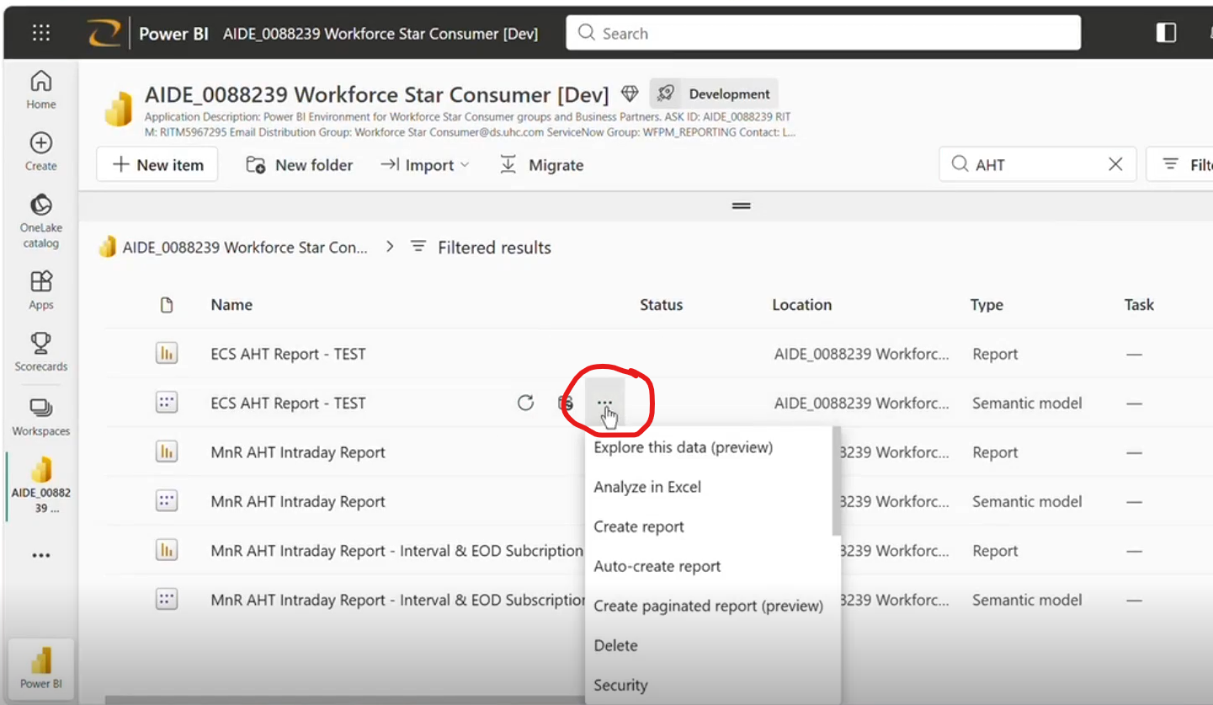
- Click Settings
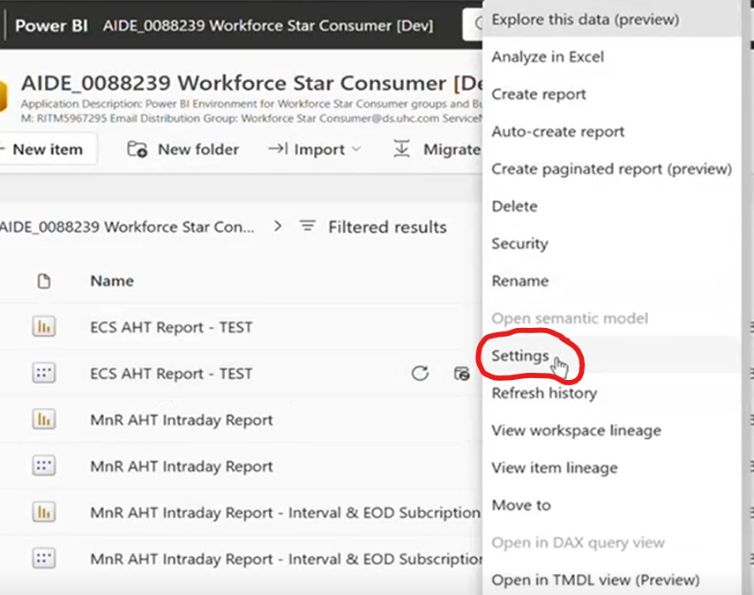
- Choose the Gateway and cloud connections on the left side
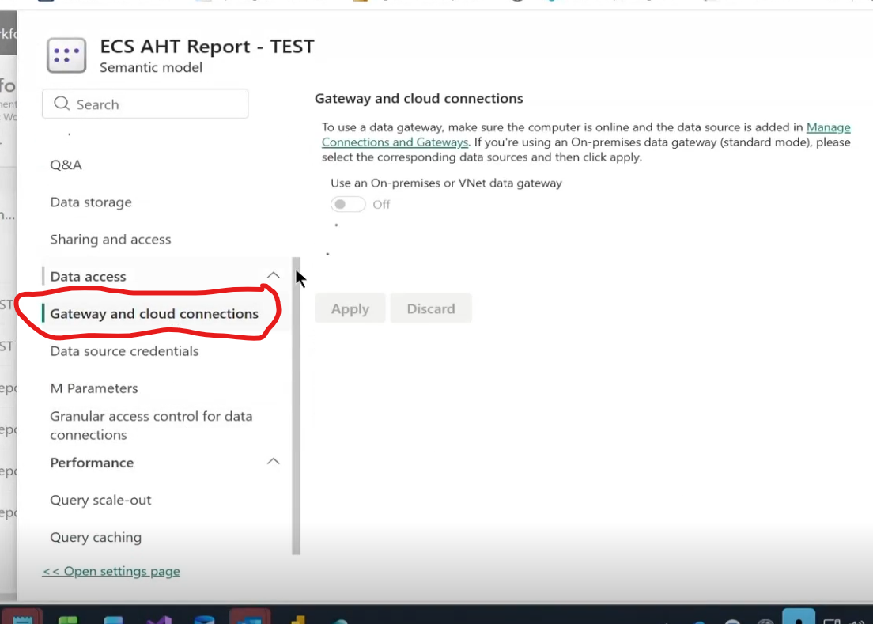
- Then connect to the server
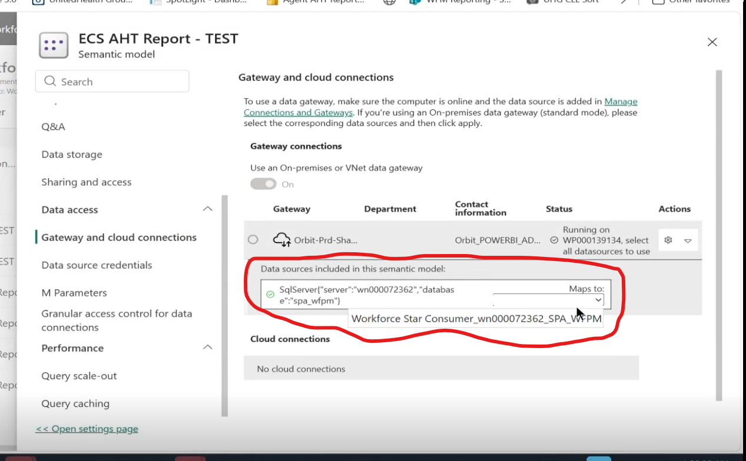

- Then click Apply
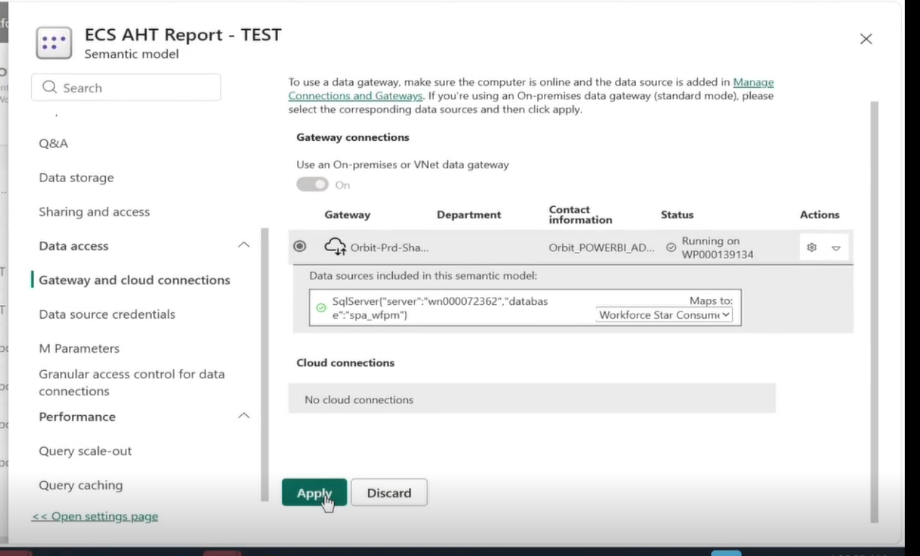

- There will be a pop up like this. Then close.
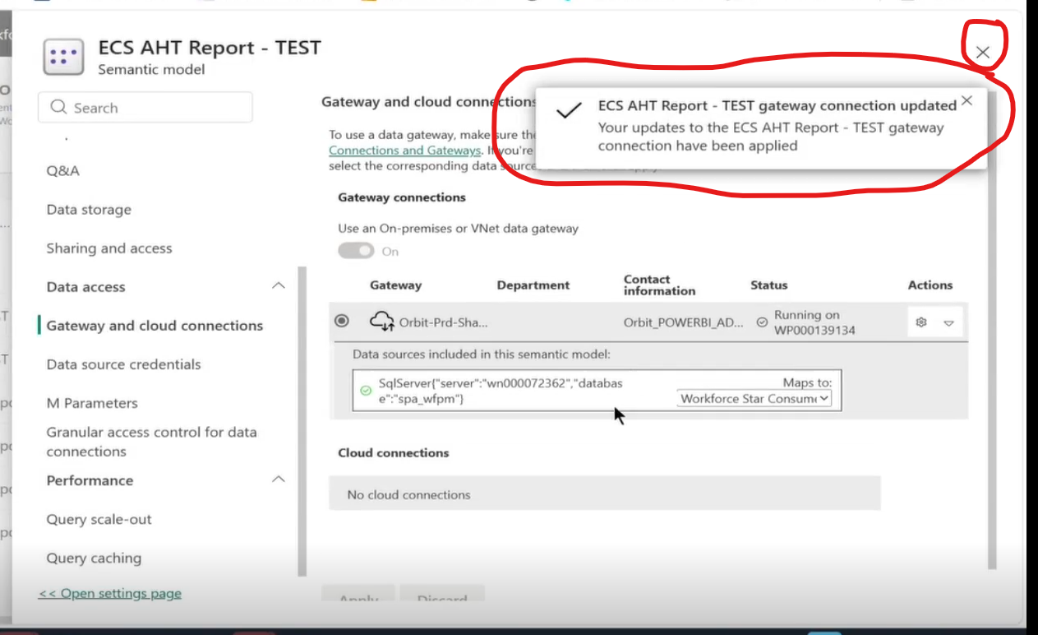
- Click again the Semenatic model
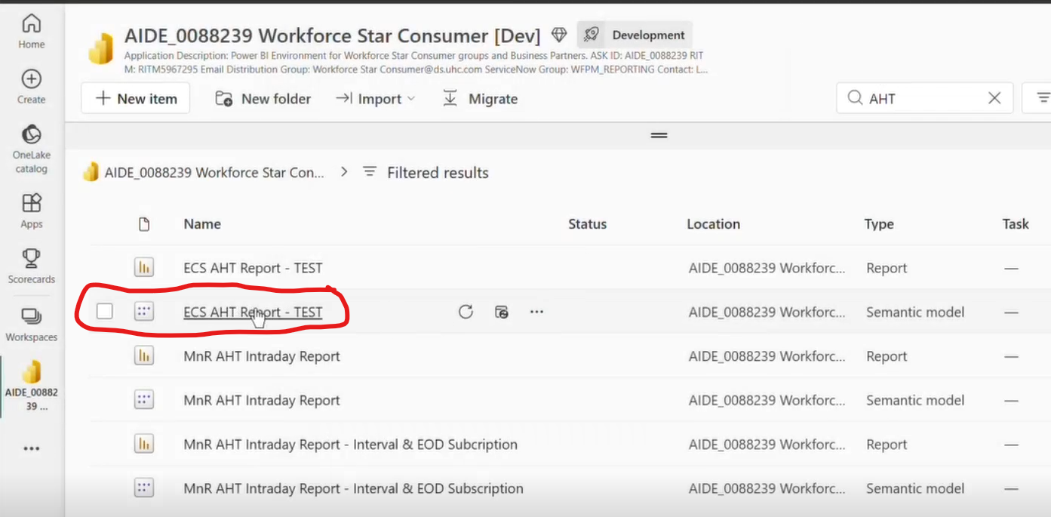

- Then go again to Workspaces
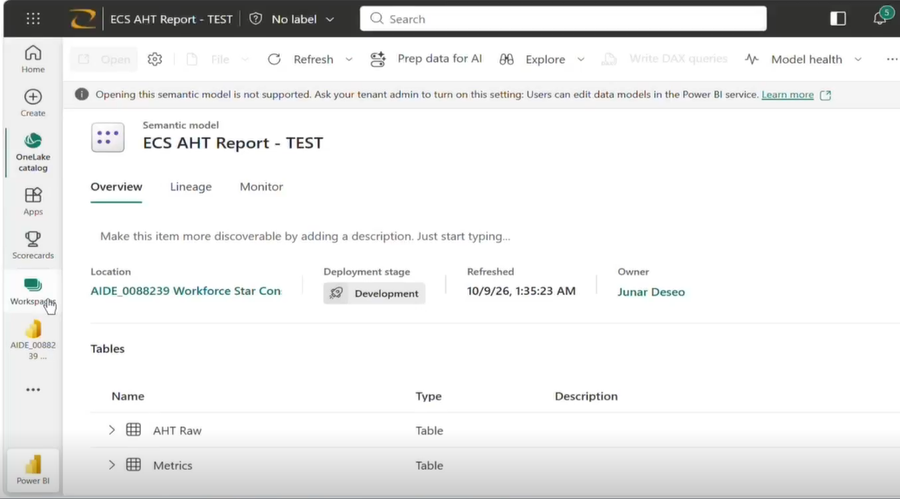
- Then click again the server where you deploy the report. AIDE_0088239 Workforce Star Consumer [Dev]
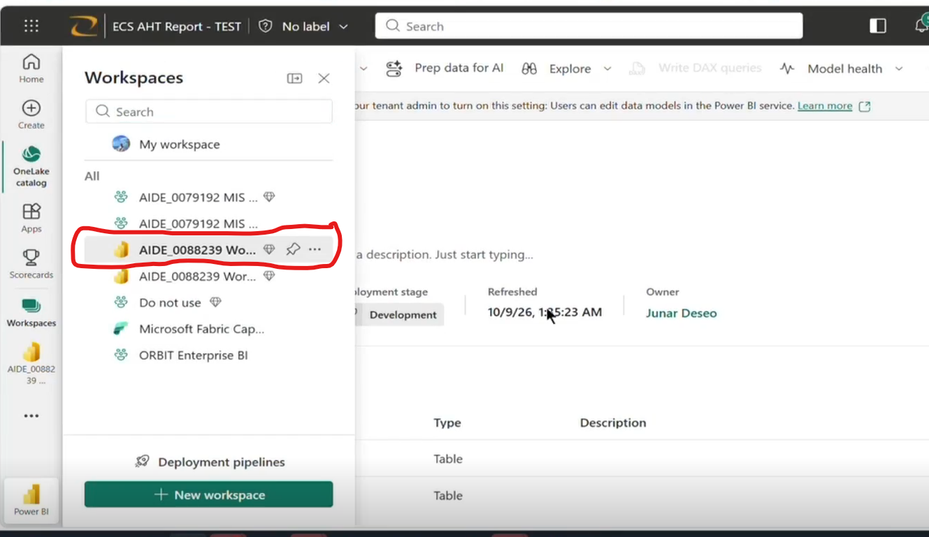
- Click Update App
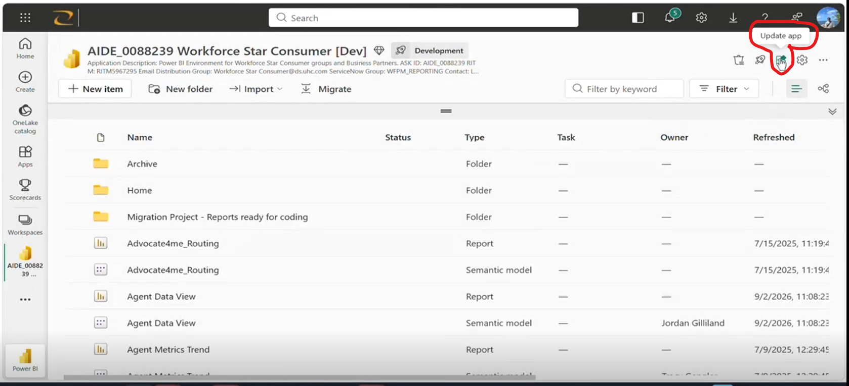
- Ignore the 1st step - Set up. Proceed to 2nd Step - Content
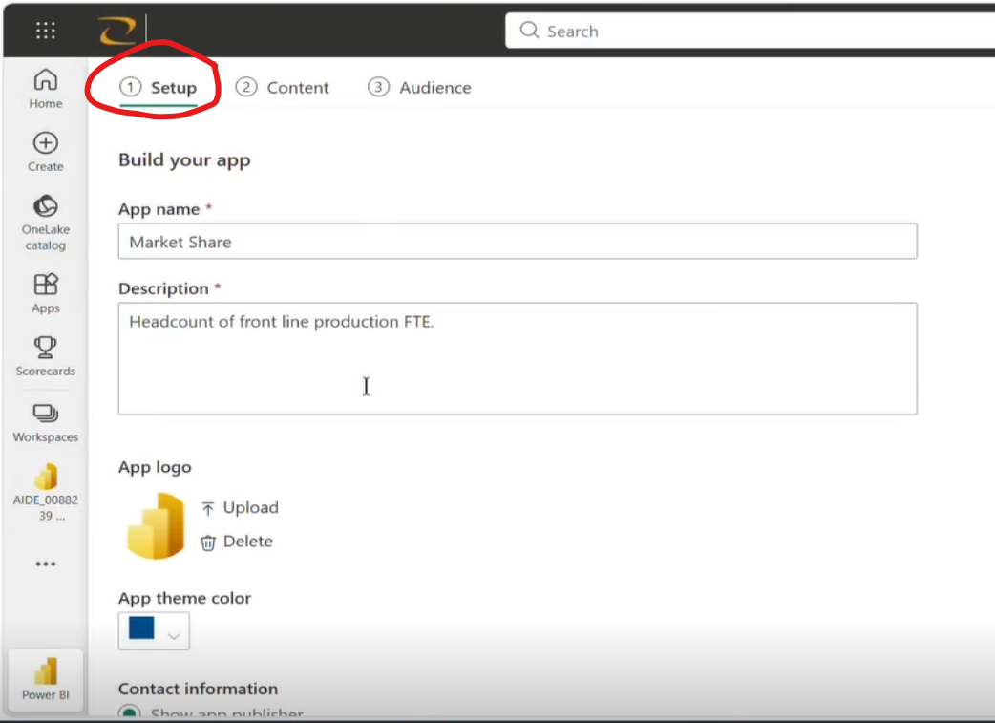

- Click Add Content
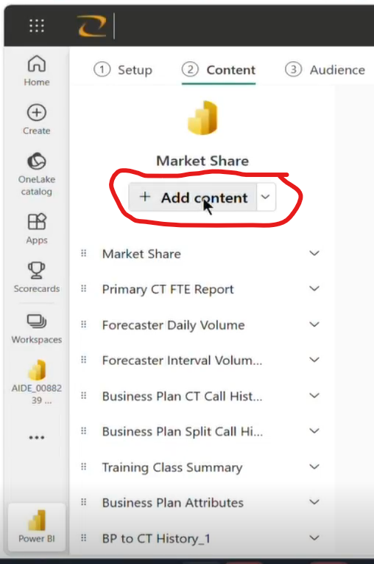
- Find the report you publish. Put check then click add.
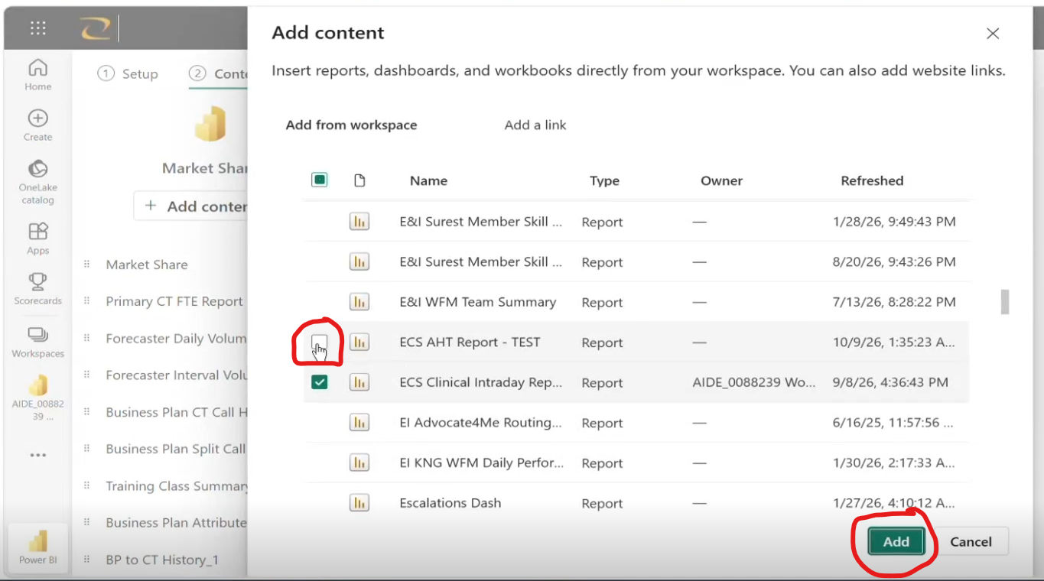
- Check if the report is already added.
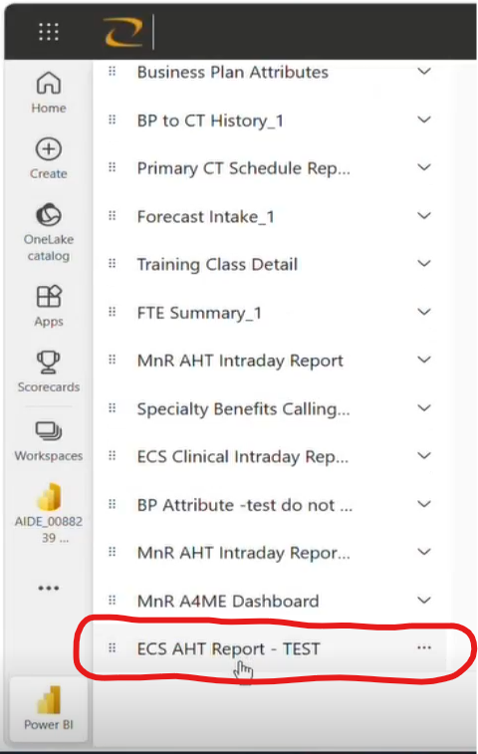
- Then go to 3rd step – Audience
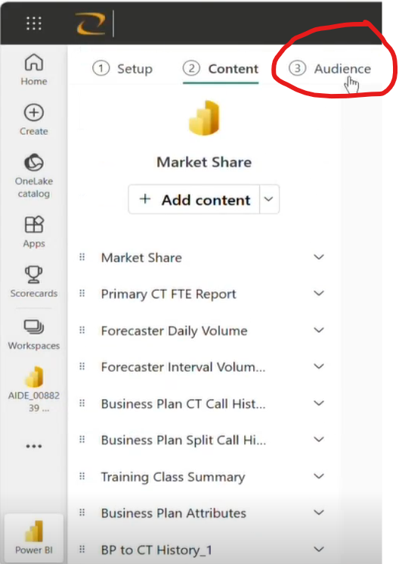
- Find the report. Click the eye to see. (to grant them access)
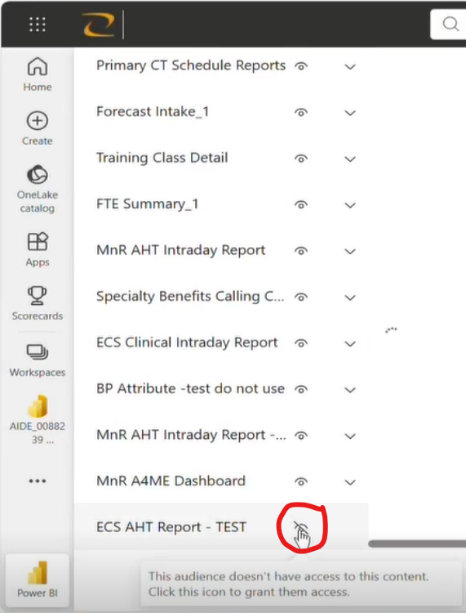

- Make sure the eye is open. Then click Update app.
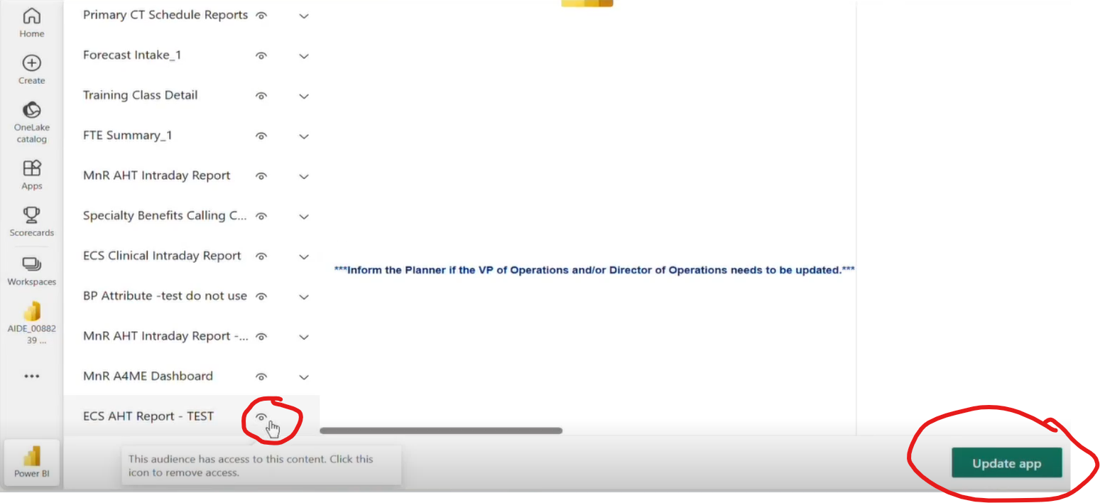
- The pop up will show. Click Update
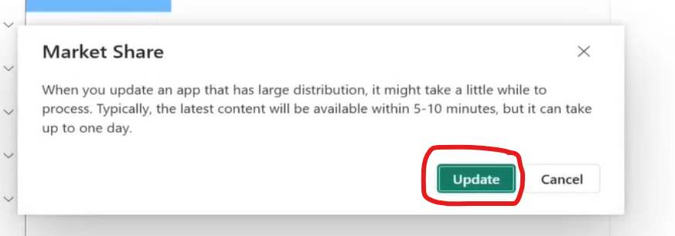
- The pop up will show. Click close. You can copy the link to give to the client to access the report.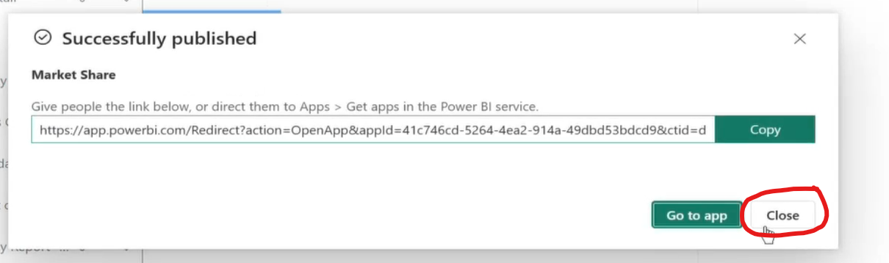
- You also need to Upload the report to Prod if the client has no access to Dev. Same steps.
- To view the report and get the link. Go to Apps
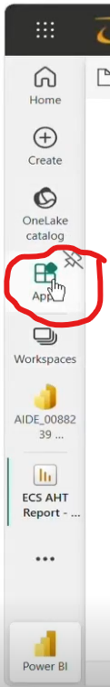
- Choose the folder where the report could be.
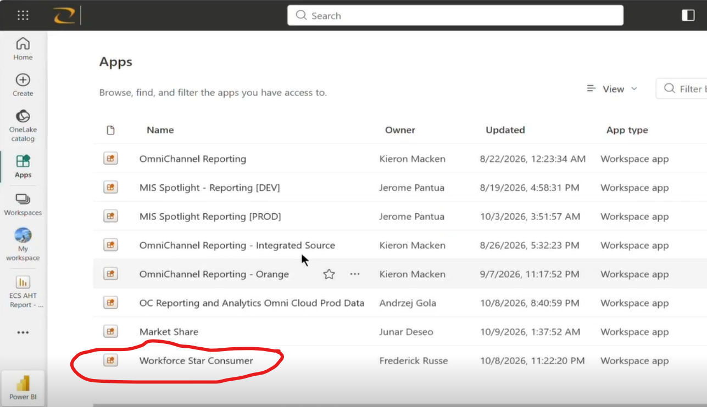
- Find the report you want to have the link. 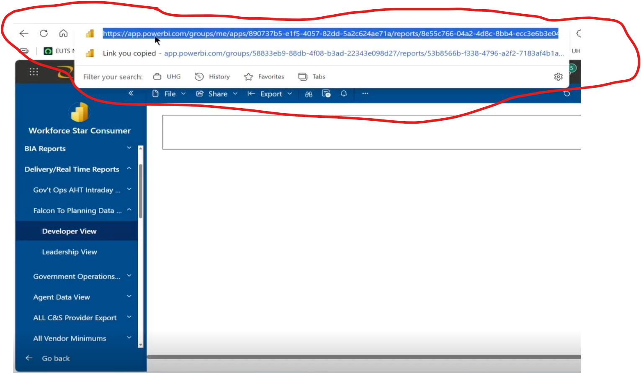

Guide To Re-deploy the report
- Click Publish
- Choose where you want to re-publish the report. In this case, we choose the AIDE_0088239 Workforce Star Consumer [Dev]
- Click replace.
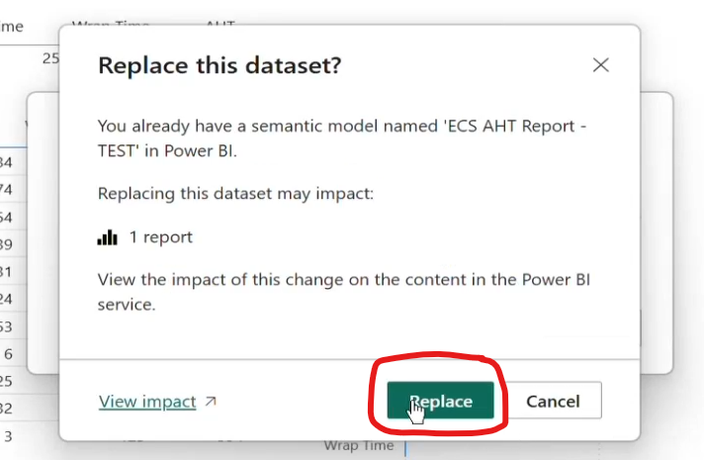

- Click Got it.
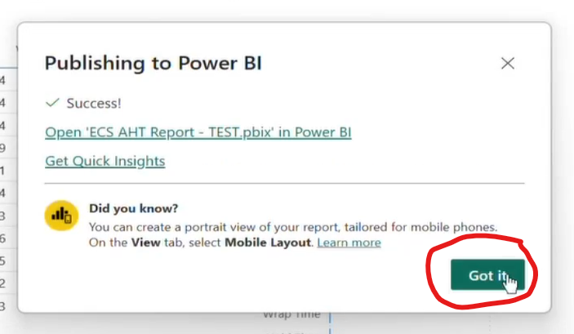
- Browse for the Power BI website. https://app.powerbi.com
- Click your Workspace
- Choose where you re-publish the report earlier. Choose AIDE_0088239 Workforce Star Consumer [Dev]
- Click Update App
- Just click the 1st , 2nd and 3rd step. No need to do anything. Just click them.


- Click the Update app. You can see it in 3rd step – Audience.
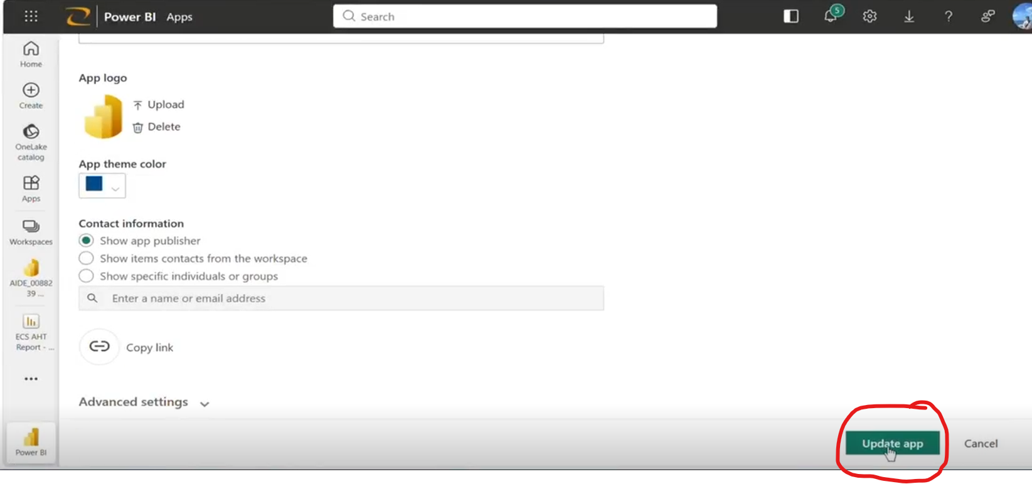
- Click Update.
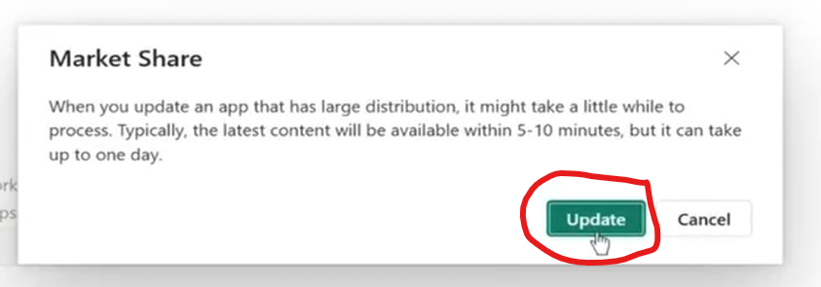
- Then Close.


